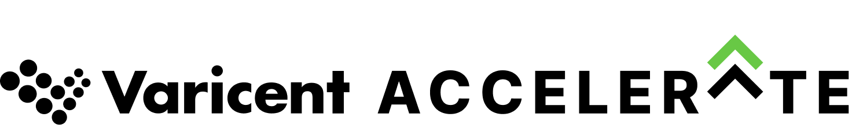

To: From:

Re: 2024 Varicent Accelerate Conference

I am writing this to request approval to attend the 2024 Varicent Accelerate Conference, scheduled for May 6-9, 2024, in Boston, MA.
Accelerate is the world’s biggest sales performance management event that is packed with opportunities for learning, networking, and professional growth. It will cover trends and strategies for resiliency, sales transformation, sales planning, incentive compensation, AI, and more to help us build a more connected path to revenue.
By attending, I am confident I will acquire industry best practices, knowledge of Varicent’s latest product features, and new skills that will help us unlock the potential of our investment in Sales Performance Management.
Attending this conference presents an invaluable opportunity. Here's why:
Access to hands-on learning and product training
The Product Lab Sessions are the perfect opportunity to improve my skills and become an expert with the Varicent solutions of our choice. These in-depth training sessions cover a variety of topics including incentives, sales planning, AI, and more. By attending, I can learn directly from the Varicent team and see how to best use the product to our advantage.
Opportunities to meet with Varicent leaders, industry experts, and peers
Accelerate provides many opportunities to meet with product experts, leadership, as well as other Varicent customers. Through networking with other customers and meeting partners, we will gather new ideas and insights to implement at our organization.
It will not only provide better understanding of our current usage, but it will give us opportunities to understand how companies like ours are taking advantage of other Varicent capabilities to manage their projects and people.
Ability to gain knowledge, improve processes and technical experience
through 50+ unique presentations
The planned sessions are designed to teach us how customers and partners are connecting revenue growth strategies to execution. Plus, Varicent product, design, services, support and other teams plan to share the state of Varicent offerings, helping us get the most from our relationship with Varicent and to reach our business goals.
The opportunity to attend Accelerate is an investment which will yield returns for myself, our team, and our organization overall. I am confident that the experiences gained from attending this meeting will pay off in driving forward some of our internal initiatives more efficiently and successfully; specifically:
- [internal initiative 1]
- [internal initiative 2]
- [internal initiative 3]
Plus, if we register by January 12, 2024, we can benefit from special pricing. The estimated total cost is $XXX broken down as follows:
- Registration Fee (early bird pricing ends Jan 12, 2024) $1300
- Hotel ($329 per night) $XXX
- Airfare $XXX
- Meals (breakfast & lunch provided 5/7-5/9, $XXX
dinner provided 5/7)
Total: $XXXX

Note: If we register 3 or more people from our organization, we will receive a discount
of $100 off per person.
On my return, I would be happy to share with the relevant stakeholders the key takeaways from the conference and practical recommendations that we can implement based on the successes of other customers.
If you need more info or have any questions, please let me know. Thank you for considering this request. I look forward to your reply.
Regards,

